Question 1
Part a
Absolute advantage is the ability to produce more of a good or service than the competitors with the same resources
Country west has an absolute advantage in production of garments because it takes six days to produce garments while country east uses ten days with the same amount of labor.
Country east has an absolute advantage in production of rice because regardless that both countries produce rice in ten days. It produces rice more cheaply than country west.
Part b
Comparative advantage is the ability of an individual country to produce a good or service at a lower opportunity cost than competitors.
Country west has a comparative advantage in production of garments because it has a lower opportunity cost of rice.
Country east has a comparative advantage in production of Rice because it has a lower opportunity cost in Garments.
Part c
Autarky price ratio in country east (5/4)
Autarky price ratio in country west (3/4)
Range of terms of trade is 0.75 to 1.25
Part d
Country west would save 2 days. Because 8-6= 2 days
Part e
Country east would produce 800/10=80 pieces of Garments and 800/8=100 pieces of rice
Country west would produce 600/6=100 pieces of garments and 600/6=75 pieces of rice.
Question 2
In a nation with K being abundant and L being scarce, with opening of trade the equilibrium rental rate rises by a greater percentage than the percentage changes in the prices of both goods, while the equilibrium wage rate rises by less than the percentage changes in the prices of both goods.” Discuss the theory behind this statement.
The theory behind this is the H-O theorem which incorporates a number of realistic characteristics of factors of production that are left out of the simple Ricardian model. The H-O model assumes private ownership of capital. Use of capital in production will generate income for the owner. We will refer to that income as capital “rents.” Thus, whereas the worker earns “wages” for his or her efforts in production, the capital owner earns rents. Even though the equilibrium rate raises by less than the price change for good and services, this theory assumes that any increase in a factor of production increase the prices of the resultant goods and services. In this case, of a 2-factor, 2 good Heckscher-Ohlin model, an influx of workers from across the border would shift the production possibility curve outward and decrease the production of the capital-intensive product.
Question 3
Define the concept of import-biased growth.
Import biased growth is a growth that expands a country’s production possibilities disproportionately in that country’s import sector.
(b) Then with the help of a diagram (with PPF and Indifference curves) discuss the impact of this type of growth on the wellbeing of the nation.
The impact of this type of trade is that it allows us to separate consumption and production points. A countryís terms of trade are defined as: TOT = Pexport/Pimport = Pe/Pi If your TOT rise (i.e., Pe rises or Pi falls), welfare rises. (i.e., you are better off). Below, the country exports cloth. If P cloth rises, what happens? (1) The production of cloth rises (2) The country’s terms of trade improves (3) Welfare increased; the country is now on a higher indifference curve. But trade could also lead to declining terms of trade (i.e., Pcloth falls relative to Pfood). Generally, any event that increases export prices Will improve your terms of trade, and anything that raises import prices hurts your terms of trade.
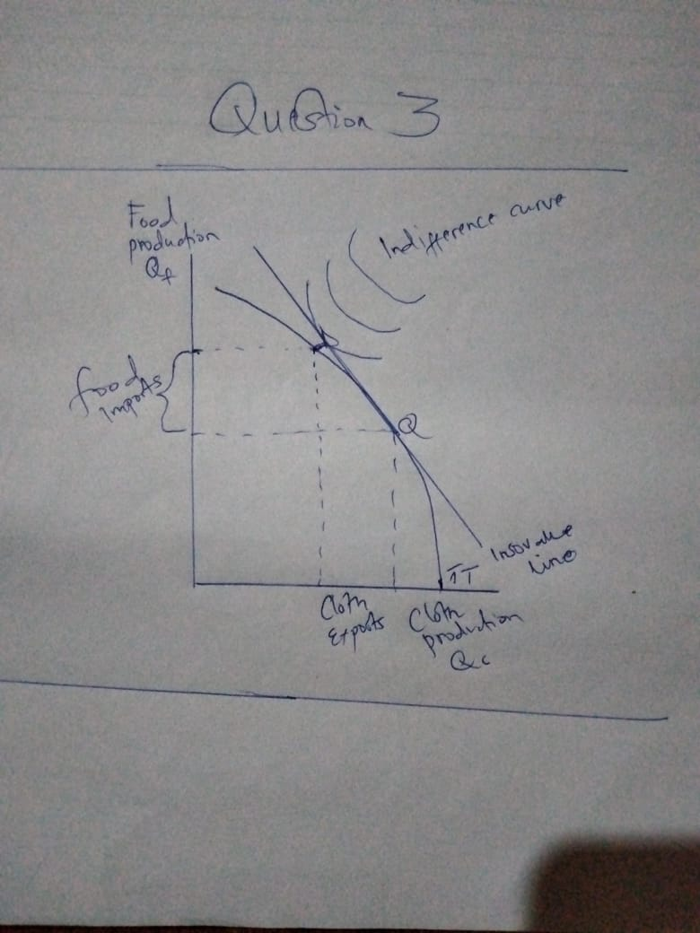

(c) Does your answer to part (b) depends on whether the growing economy is small or large? Discuss fully.
Yes, a growing economy increases the welfare of a country therefore it depends if the economy is large. In a large economy, the GDP is rising, and the economy is in solid shape, and the nation is moving forward. On the other hand, if gross domestic product is falling, the economy might be in trouble, and the nation is losing ground.
Question 4
(a) What is the difference between inter-industry and intra- industry trade?
Inter-industry is a trade belonging to different industries like coffee an agricultural product produced in one country with technological equipment produced in another country due to the countries’ competitive advantage while intra-industry is a trade of products that belong to the same industry, for instance similar products are produced from the same industry as a result of new technology.

(b) Why does inter-industry trade dominate trade flows when differences between countries’ factor endowments are significant, but intra-industry trade tends to dominate trade flows when these differences are small or non-existent?
Inter-industry trade increases the varieties of product in the same product which benefit both business and consumers, innovation of the industry thus assisting it in case of economy short-term fluctuations and gives opportunities for businesses to benefit from economies of scale where countries gets more economic benefits if they concentrate on producing specific types of products within specific range, according to their comparative advantages rather than producing all ranges of specific products. While intra-industry trade produce product of different type but in same industry which make customers view them as same product.
(c) Assume that the exportable sector in a nation is characterized by internal economies of scale.
(i) Sketch a diagram to show the demand - supply curve for this sector and pinpoint the pre-trade equilibrium point.
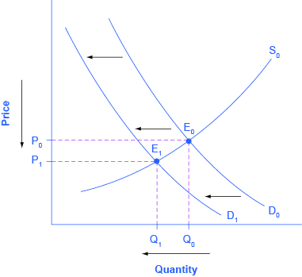
(ii) Show, in the presence of economies of scale, as trade opens the world price of this nation’s exports declines.
The demand curve D0 and the supply curve S0 show the original relationships. In this case, the analysis is performed without specific numbers on the price and quantity axis. The new equilibrium (E1) occurs at a lower quantity and a lower price than the original equilibrium (E0).
Question 5
Suppose when Indonesia opens to trade, it imports airplanes, a capital-intensive good from the rest of the world (ROW).

(a)According to the Heckscher-Ohlin theorem, is Indonesia capital-abundant or labor-abundant? Briefly explain.
Indonesia is a is labor abundant because its relative endowment of labor is large compared to other countries. It has enough supply of labor compared to other countries and that’s why they import more airplanes.

(b) Assuming that consumers tastes are the same in all countries draw a diagram to illustrate the pre- trade equilibria for Indonesia and the (ROW.
(c) In your diagram show the post- trade equilibrium points for each of the two countries including the production points, consumption points, the international price, and the trade triangles.
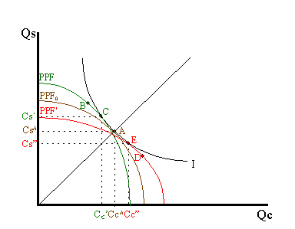
Explanation
The difference in resource endowments is sufficient to generate different PPFs in Indonesia and other countries such that equilibrium price ratios would differ in autarky. To see why, imagine first that Indonesia and other countries are identical in every respect. This means they would have the same PPF (depicted as the brown PPF0 in the adjoining figure), the same set of aggregate indifference curves and the same autarky equilibrium. Given the assumption about aggregate preferences, that is U = CCCS, the indifference curve, I, will intersect the countrys' PPFs at point A, where the absolute value of the slope of the tangent line (not drawn), (PC/PS), is equal to the slope of the ray from the origin through point A. The slope is given by CSA/CCA. This shows that Indonesia will have more labor and less capital than initially. This implies that K/L> K*/L*, or that other countries is capital-abundant and Indonesia is labor-abundant.
Indonesia experiences an increase in L and a decrease in K. These changes will cause an increase in output of the labor-intensive good (i.e., piloting) and a decrease in output of the capital-intensive good (airplanes). If price were to remain constant, production would shift from point A to D in the diagram and the Indonesia PPF would shift from the brown PPF0 to the red PPF*.
6. “In Ricardian trade model, the terms of trade are independent of the demand side and solely determined by the supply side of the economy.” Evaluate by using a diagram.
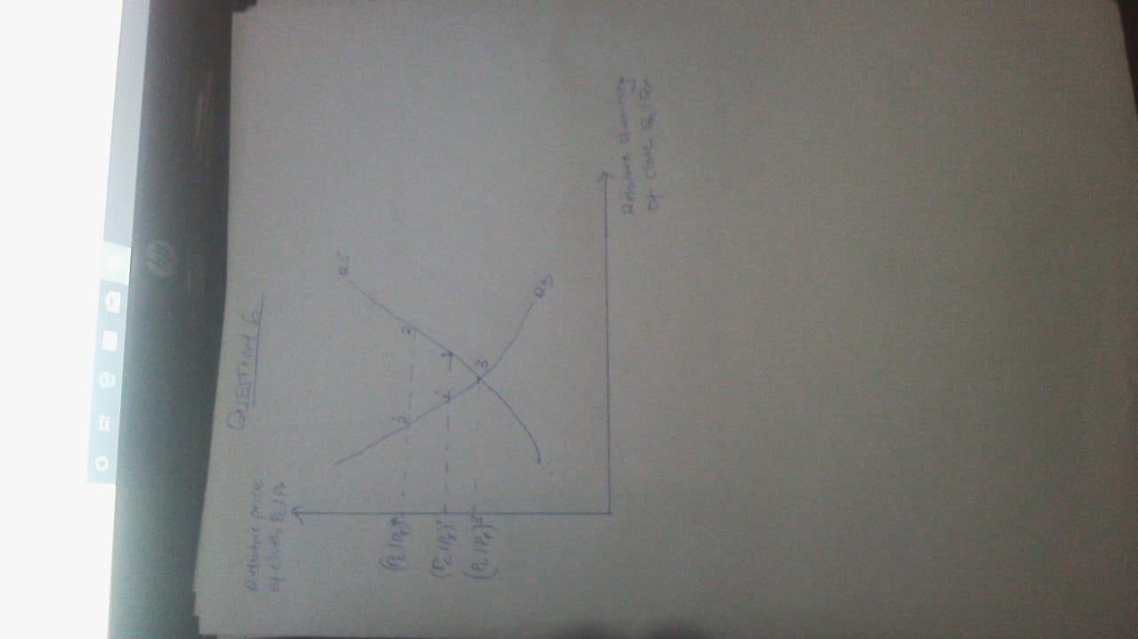
Question 7
Assume a large labor abundant country such as China levies a tariff on its capital-intensive imports
- Discuss the impact of this tariff on the country’s production and consumption of its imports as well as its volume of imports. Illustrate your answer using a partial equilibrium diagram.
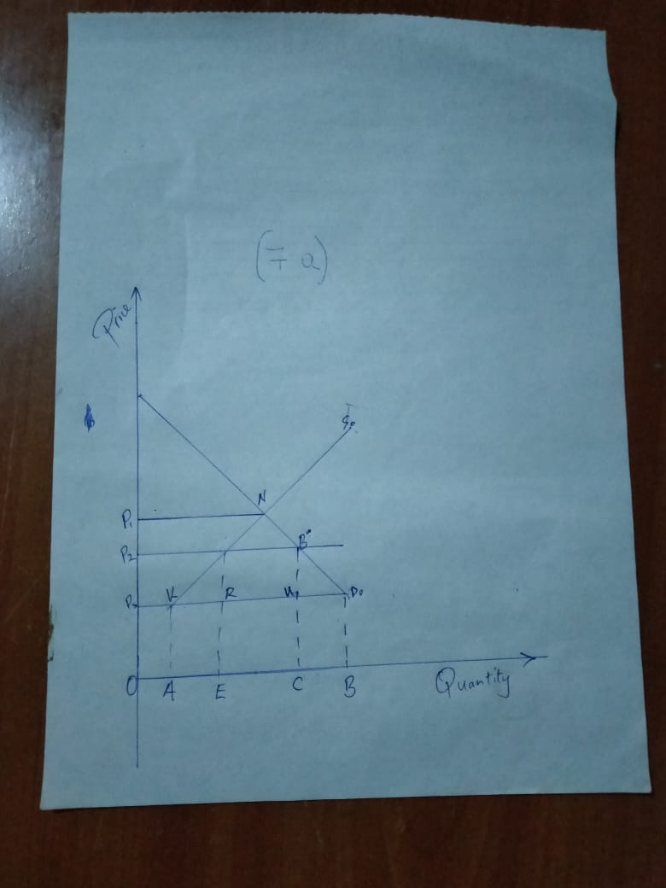
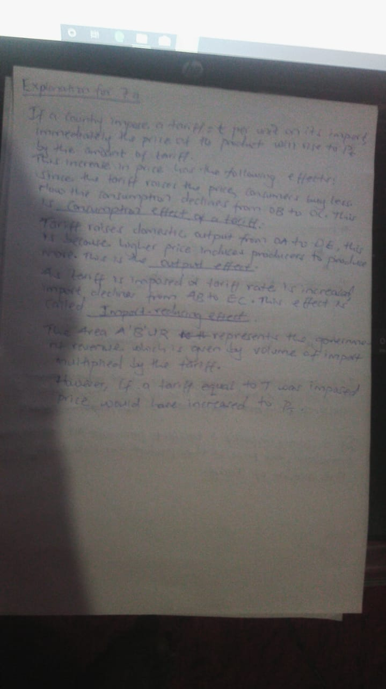
(b) Discuss whether this country has been made better off or worse off as a result of this tariff. Be detailed
The country will be worse off because tariffs will increase the prices of the imports thus increasing the cost of production which will in turn lead to reduced volume produced which will be sold at very high prices leading to reduced sales. Thus, bringing about unemployment wage.
(c) Would your answer above be any different if China instead of a tariff had imposed an import quota of equal magnitude?
There would be no difference if china had imposed an import quota instead of a tariff. Because the effects of a tariff is the same as that of an import quota.

